English 11:
Animal Farm by George Orwell
Background Webquest

Introduction: This webquest was created to help students gain a better understanding of the historical context for the novel, as well as to gain some insight into the author’s background.

Task: You will explore various websites to answer questions on this worksheet. Through your research, you will discover and learn about the political and economic causes of the Russian Revolution, and about the author, George Orwell.

Part 1 – Author Background

Directions: Visit the following websites to find information about the author.

http://www.bbc.co.uk/history/historic_figures/orwell_george.shtml
http://www.spartacus.schoolnet.co.uk/Jorwell.htm

Part 2 – Historical Background
Directions: Visit the following websites to find information about the historical context for the novel.

http://www.pbs.org/wgbh/peoplescentury/episodes/redflag/description.html
http://en.wikipedia.org/wiki/Russian_Revolution
http://en.wikipedia.org/wiki/Joseph_Stalin
http://gopcapitalist.tripod.com/socialistmyth.html#socialism
http://en.wikipedia.org/wiki/Vladimir_Lenin

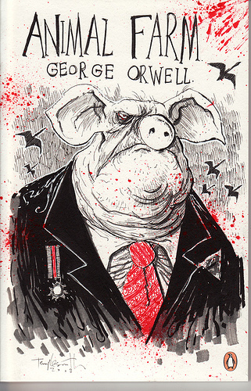
Evaluation: You will turn in the worksheet to be evaluated for a formative grade.

Conclusion: With every world conflict, we learn how we must improve our abilities to coexist. As part of this assignment you will explore a variety of resources about this important event in world history. You will gain some insight and important background information about the Russian revolution and its impact on the author, George Orwell.

English 11: Animal Farm by George Orwell Name___________________________
Background Webquest Date ________________ Hr ________

Part 1 – Author Background

- What is George Orwell’s real name?

- What is the name of the first book he published?

- In what year was Animal Farm published?

- What experience did Orwell have with Stalin’s government? How did this become a motivation for him to write Animal Farm?

5. What are some of the topics Orwell chose to write about? List some other titles of his works here.

Part 2 – Historical Background
1. Identify the following people:
- Czar Nicholas II
- Karl Marx
- Joseph Stalin
- Leon Trotsky
- Vladimir Lenin
- Bolsheviks
2. Identify and define the following terms:
- KGB
- Socialism
- Marxism
- Communism
- Fascism
- Capitalism
3. How did Czar Nicholas II feel about democracy?

4. What were working conditions in Russia like with Nicholas II as a leader?

5. What was Bloody Sunday?
6. What happened during the February Revolution of 1917 (first phase of the Russian Revolution)?

7. What did Karl Marx believe or say about religion?

8. Marx helped to write The Communist Manifesto, which stated that all men were born free but …. (complete the statement)

9. What happened during the October Revolution of 1917 (second phase of the Russian Revolution)? What were the outcomes of this revolution?

10. Communism would probably function well if humans did not have the unfortunate tendency toward… (complete the statement)

11. Leon Trotsky wanted to improve life in Russia. He worked closely with the leader who took control after the Revolution. What is this leader’s name?

12. Who ordered Trotsky’s assassination?

13. What title was Stalin given in 1922? By the late 1920’s, what was his role?

14. What happened in the 1930’s during the Great Terror or Great Purge?

15. Stalin used a secret police force to force support of him and to kill the disobedient. We, in recent years, think of the KGB, but what four letter acronym were they called in his time?

16. What are the common goals/failures of socialism and communism? (hint: utopia means “an ideally perfect place, especially in its social, political, and moral aspects”)

17. What became of the Czar and his family during/after the Revolution?

18. Who succeeded Lenin as leader of Russia?
19. What were the major long-term outcomes of the Russian revolution?

